**CE 650 C – Assignment 1**

**Part 1**

Log in to your github account and click on “New Repository” to create a new repository.

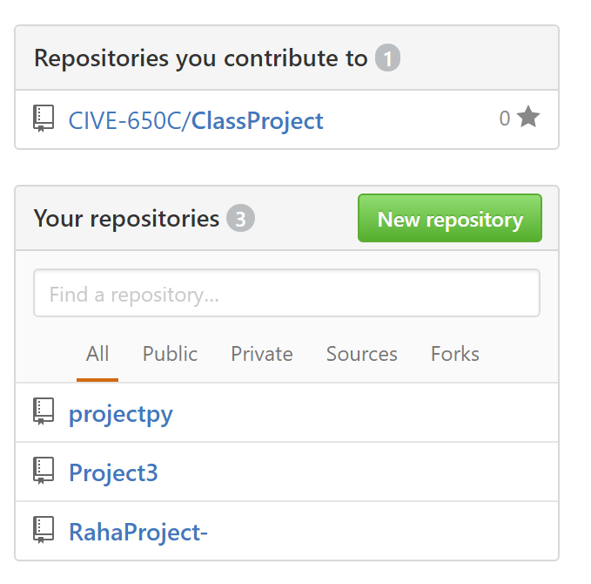

Assign a name to the repository you want to create. You can change the settings in the window below. Make it public and initiate it with a README.

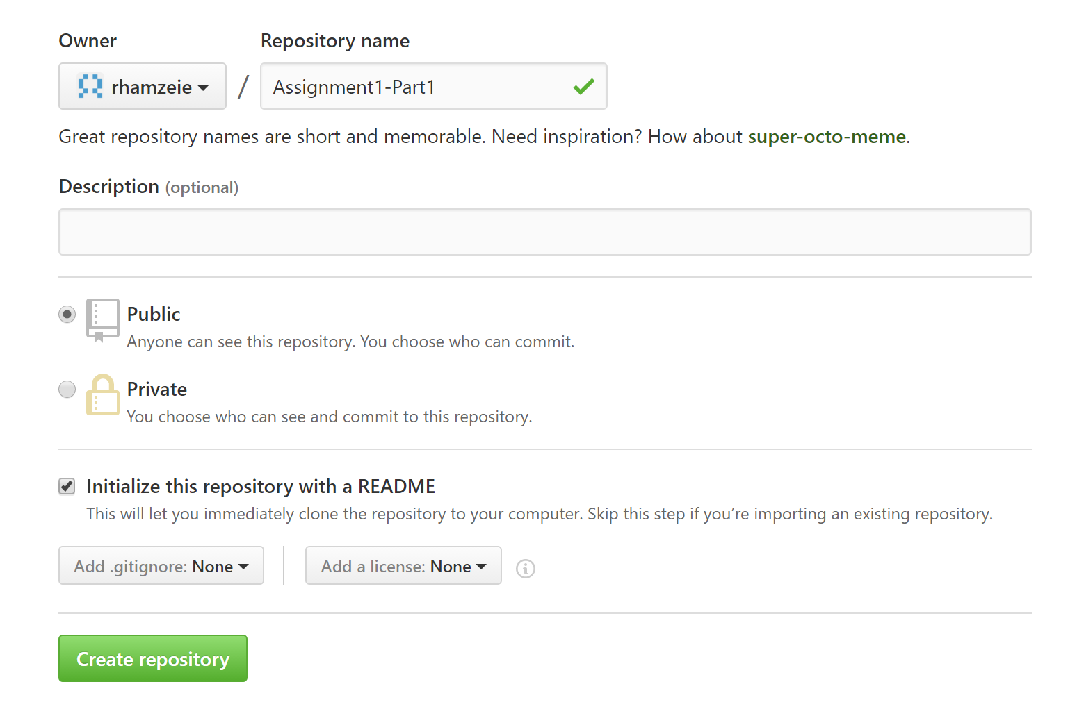

From putty access the machine you were assigned to (“user11, pass: classpass”).

In order to clone the repository, you just created, click on the green tab “Clone or download” and copy the link using the icon near the URL.

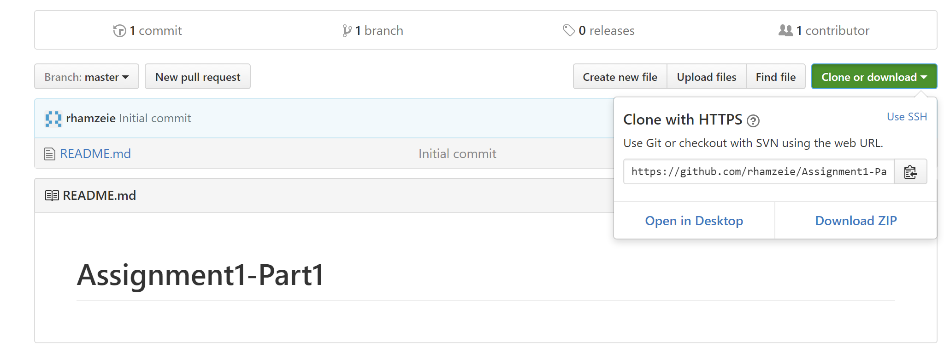

Now in putty, write git clone and paste the link you copied to clone the repository you created:

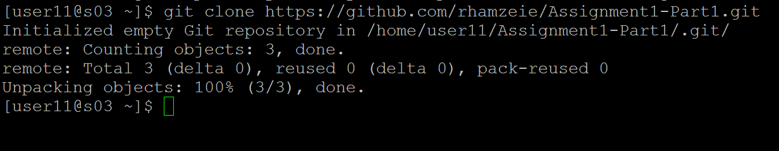

To add a new file, first change director using cd command to the repository you just created. Type vi Raha-NewFile, then type ESC>:wq to save your work.

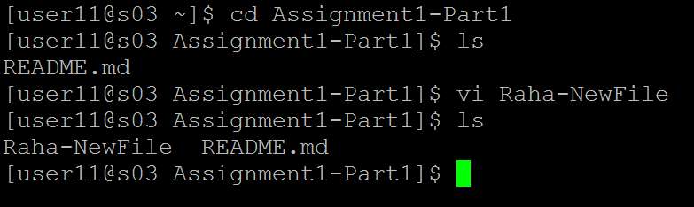

To start tracking use the command git add.

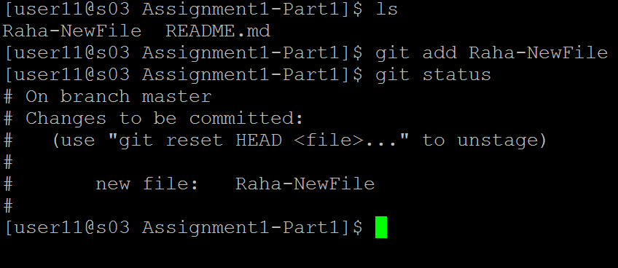

Then use git commit to do a commit. I wrote “a commit has been made for part1”.

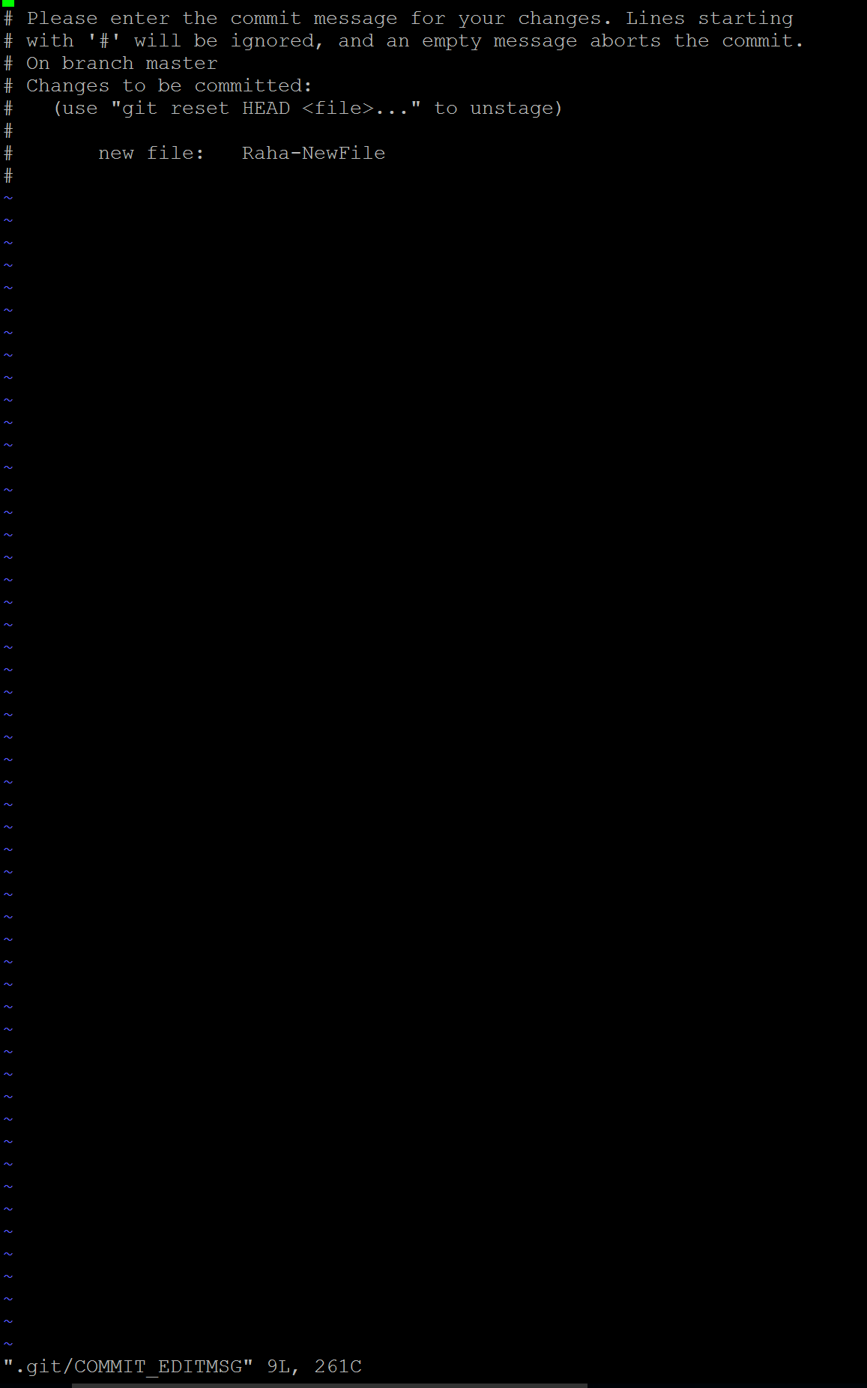

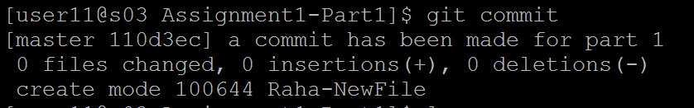

Finally, all the files and changes were pushed to the github.

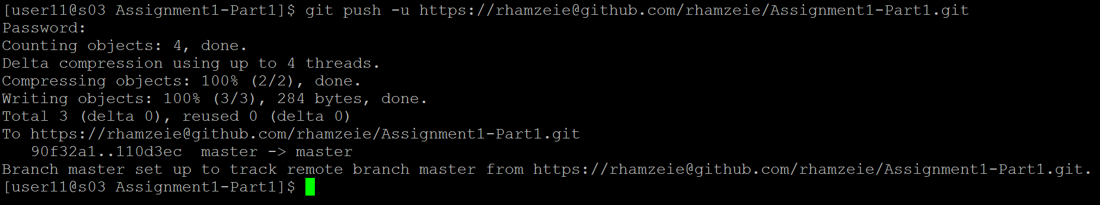

The last section was to add some fixes and then do a merge. As a result following sentences were added to the README.md file.



Ultimately, the merge process was done doing the following steps:

